PF lab assignment #11

Mohammad Yehya Hayati, 21K-3309

Table of Contents

**Question #1** 2

**Question #2** 5

**Question #3** 6

**Question #4** 7

**Question #5** 8

**Question #6** 10

**Question #7** 11

**Question #8** 13

# **Question #1**

#include <stdio.h>

struct Register

{

int CourseID;

char CourseName[100];

};

struct student

{

int stdID;

char FName[100];

char LName[100];

long cellno;

char email[100];

struct Register R;

};

int main()

{

int i , n = 5;

struct student s[5];

for (i = 0 ; i < n ; i++)

{

printf("Enter the student ID of student %d: ",i+1);

scanf("%d",&s[i].stdID);

printf("Enter the First Name of student %d: ",i+1);

getchar();

gets(s[i].FName);

printf("Enter the Last Name of student %d: ",i+1);

gets(s[i].LName);

printf("Enter the Cell Number of student %d: ",i+1);

scanf("%d",&s[i].cellno);

printf("Enter the email of student %d: ",i+1);

getchar();

gets(s[i].email);

printf("Enter Course ID: ");

scanf("%d",&s[i].R.CourseID);

printf("Enter the Course Name: ");

getchar();

gets(s[i].R.CourseName);

}

for (i = 0 ; i < n ; i++)

{

printf("Student ID of Student %d : %d\n",i+1,s[i].stdID);

printf("The First Name of Student %d : %s\n",i+1,s[i].FName);

printf("The Last Name of Student %d : %s\n",i+1,s[i].LName);

printf("The cell number of Student %d : %d\n",i+1,s[i].cellno);

printf("The Email of Student %d is: %s\n",i+1,s[i].email);

printf("The Course Id is: %d\n",s[i].R.CourseID);

printf("The Course Name is: %s\n",s[i].R.CourseName);

}

}

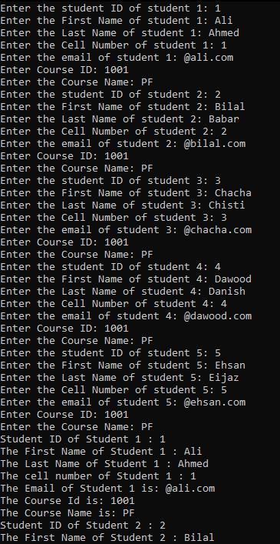

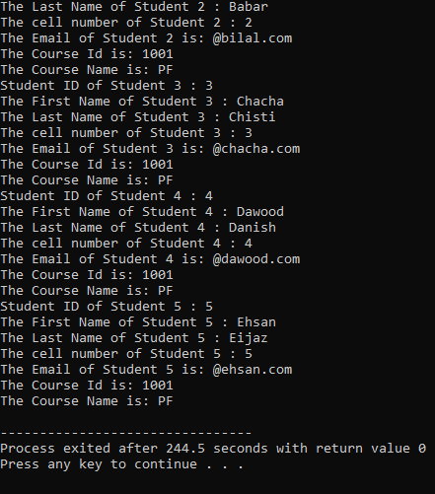

# **Question #2**

#include <stdio.h>

void swapped(int *aPtr, int *bPtr, int *cPtr);

int main()

{

int a,b,c;

printf("Enter value of num1: ");

scanf("%d",&a);

printf("Enter value of num2: ");

scanf("%d",&b);

printf("Enter value of num3: ");

scanf("%d",&c);

printf("Before Swapping: num1 is: %d, num2 is: %d, num3 is: %d\n",a,b,c);

swapped(&a,&b,&c);

printf("After Swapping: num1 is: %d, num2 is: %d, num3 is: %d",a,b,c);

}

void swapped(int *aPtr, int *bPtr, int *cPtr)

{

int temp;

temp = *aPtr;

*aPtr = *bPtr;

*bPtr = *cPtr;

*cPtr = temp;

}

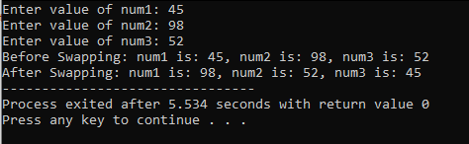

# **Question #3**

#include <stdio.h>

int main()

{

int n;

printf("Enter how many numbers you want to enter: ");

scanf("%d",&n);

int arr[n],*ptr = arr , sum;

for (int i = 0 ; i < n ; i++)

{

printf("Enter value at postion %d: ",i+1);

scanf("%d",&arr[i]);

sum += *(ptr + i);

}

printf("The Sum is: %d",sum);

}

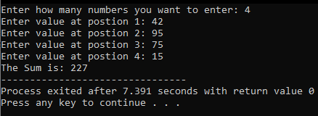

# **Question #4**

#include <stdio.h>

int main()

{

int n;

printf("Enter how many numbers you want to enter: ");

scanf("%d",&n);

int arr[n],*ptr = arr , min = 9999 ,max = -9999;

for (int i = 0 ; i < n ; i++)

{

printf("Enter value at postion %d: ",i+1);

scanf("%d",ptr + i);

if (*(ptr + i) > max)

{

max = *(ptr + i);

}

if (*(ptr + i) < min)

{

min = *(ptr + i);

}

}

printf("The Min is: %d\nThe Max is: %d",min,max);

}

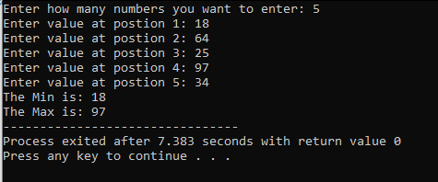

# **Question #5**

#include <stdio.h>

float add(float a, float b);

float sub(float a, float b);

float mult(float a , float b);

float div(float a , float b);

int main()

{

int n;

float num1,num2;

float (*ptr[4])(float , float);

ptr[0] = &add;

ptr[1] = &sub;

ptr[2] = &mult;

ptr[3] = &div;

do

{

printf("Enter 1(To add) 2(To Subtract) 3(To Multiply) 4(Divide): ");

scanf("%d",&n);

}

while (n < 0 && n > 3);

n--;

printf("Enter Num1: ");

scanf("%f",&num1);

printf("Enter Num2: ");

scanf("%f",&num2);

printf("%.2f",ptr[n](num1,num2));

}

float add(float a, float b)

{

return a+b;

}

float sub(float a, float b)

{

return a-b;

}

float mult(float a , float b)

{

return a*b;

}

float div(float a , float b)

{

return a/b;

}

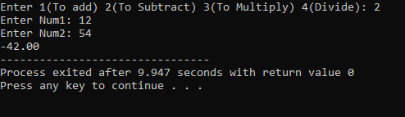

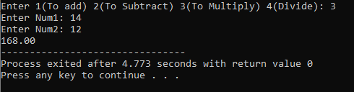

# **Question #6**

#include <stdio.h>

#include <string.h>

int *WordCount(char *Text, int *size);

int count = 1;

int main()

{

char sentence[100];

int size,*counter;

int *(*ptr)(char* , int*);

ptr = WordCount;

printf("Enter a String: ");

gets(sentence);

size = strlen(sentence);

counter = ptr(sentence , &size);

printf("You have entered %s\nTHERE ARE %d WORDS IN THE STRING",sentence,*counter);

}

int *WordCount(char *Text, int *size)

{

for (int i = 0 ; i < *size ; i++)

{

if ( *(Text + i) == ' ')

{

count++;

}

}

return &count;

}

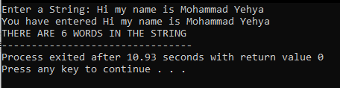

# **Question #7**

#include <stdio.h>

void SortFunction(int *arr, int *size, int order);

int main()

{

int n,ord;

printf("Enter the number of elements: ");

scanf("%d",&n);

int a[n];

for (int i = 0 ; i < n ; i++)

{

printf("Enter value of element %d: ",i+1);

scanf("%d",&a[i]);

}

do

{

printf("Enter 1 for Asscending order and 2 for Descending order: ");

scanf("%d",&ord);

}

while (ord != 1 && ord != 2);

SortFunction(a,&n,ord);

printf("After sorting: \n");

for (int j = 0 ; j < n ; j++)

{

printf("Value at postion %d: %d\n",j+1,a[j]);

}

}

void SortFunction(int *arr, int *size, int order)

{

int temp;

for (int i = 0 ; i < *size ; i++)

{

for (int j = i ; j < *size ; j++)

{

if (order == 1)

{

if (*(arr+j) > *(arr+j+1))

{

temp = *(arr+j);

*(arr+j) = *(arr+j+1);

*(arr+j+1) = temp;

}

}

else if (order == 2)

{

if (*(arr+j) < *(arr+j+1))

{

temp = *(arr+j);

*(arr+j) = *(arr+j+1);

*(arr+j+1) = temp;

}

}

}

}

}

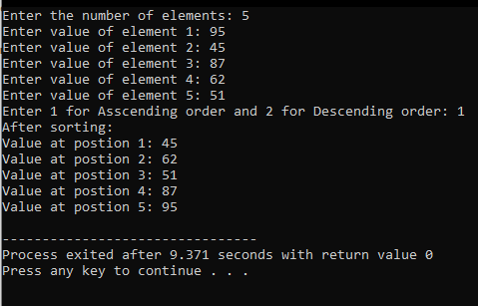

# **Question #8**

#include <stdio.h>

#include <stdlib.h>

#include <string.h>

int main()

{

char *ptr;

int N;

printf("Enter the total number of characters in your name {First Name + Last Name}: ");

scanf("%d",&N);

char name[N];

printf("Enter name: ");

getchar();

gets(name);

ptr = (char*)calloc(N,sizeof(char));

strcpy(ptr,name);

printf("The string entered dynamically is: \n");

for (int j = 0 ; j < N ; j++)

{

printf("%c",*(ptr + j));

}

}

